EMBARGOED UNTIL JANUARY 8th, 2024, AT 9:30PM GMT
Sennheiser triples down at CES 2024
The Sennheiser brand today reveals a trio of dynamic devices for high-performance audio enthusiasts.
Marlow, United Kingdom, January 8th, 2024 - The all-new MOMENTUM True Wireless 4, ACCENTUM Plus, and MOMENTUM Sport make their debut at the Consumer Electronics Show, ushering in a new generation of feature-packed devices. The Sennheiser brand showcases premium earbuds and headphones stuffed with state-of-the-art technology for power users, bringing their acoustics expertise to the forefront of a connected, always-on world.
MOMENTUM True Wireless 4
Loaded with more than a dozen enhancements and larger-than-life sound, MOMENTUM True Wireless 4 is Sennheiser’s most capable earbud yet. It delivers unparalleled sound for the connected audio aficionado, with an impressive roster of connectivity built on the Qualcomm® S5 Sound Gen 2 platform and Snapdragon Sound™ Technology for aptX™ lossless sound quality and ultra-low latency.
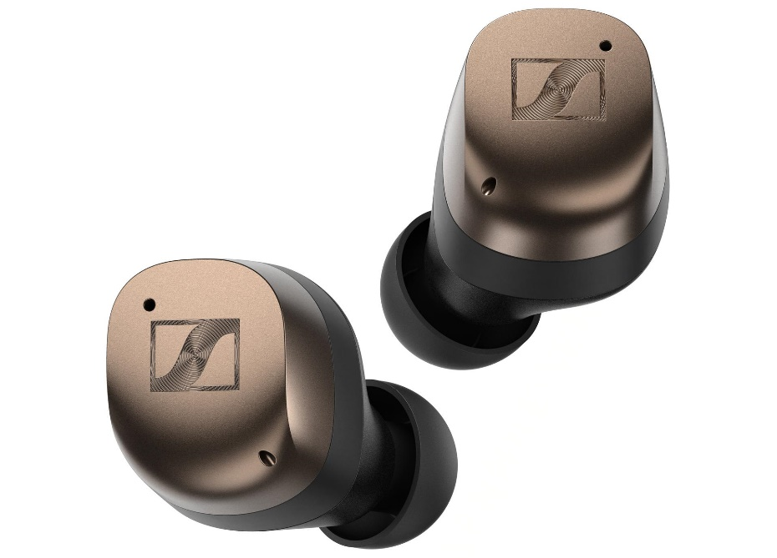

The Bluetooth® 5.4 earbuds will also bring Auracast™ support and an overhauled antenna design for exceptional signal continuity while on the go. Improved Adaptive ANC, evolved tuning, and an upgraded battery system make them an everyday companion for all of life’s adventures, among other practical enhancements. The fourth-gen MOMENTUM buds boast 7.5 hours of continuous audiophile-inspired listening, a Qi charging case, and quick charging over USB-C. MOMENTUM True Wireless 4 will be available in three colourways; black copper, metallic silver, and graphite—and will be available to pre-order on February 15th for £259.99 / €299.99 EUR.
ACCENTUM Plus
The new ACCENTUM Plus prioritises a premium headphone listening experience for less. The Bluetooth® 5.2 headphones emphasise outstanding sound quality, battery life and versatile connectivity—supporting all popular codecs including aptX™ Adaptive for optimum sound no matter where you decide to use their 50 hours of listening time per charge. A touch-enabled earcup—also used in the flagship MOMENTUM series—offers intuitive feature control without needing to search for buttons or dive into menus.
For power users, multipoint connectivity, wind-reduction and adjustable side-tone allows wearers to adapt to the world around them. Adaptive ANC optimises its noise target to constantly adjust to changes in the ambient noise environment around the wearer, reducing distractions so that the subtle details in your content shine through. And for those times when wireless listening is not permitted, an audio cable is included to tap into in-flight entertainment systems or other headphone outputs—the entire package stows away in the included travel case. ACCENTUM Plus will be available in black and white colourways and be available from February 20th for £199.99 / €229.99 EU.
MOMENTUM Sport
Pulse-pounding Sennheiser sound is supercharged with real-time biometric feedback in MOMENTUM Sport, a new true wireless earbud optimised for fitness. It integrates both a photoplethysmography (PPG) heart rate sensor and a body temperature sensor that can each output critical data to popular fitness apps and devices. MOMENTUM Sport’s heart rate data connects and integrates seamlessly with many popular sport devices and apps, such as Apple Watch/Health, Garmin Watch/Connect, Strava, Peloton and more. For the first time ever in a non-Polar product, users will be able to enjoy full access to Polar’s elite biosensing capabilities and data analytics—including Body Temperature—offering real-time insights during training and deeper offline analysis via the Polar Flow app ecosystem.

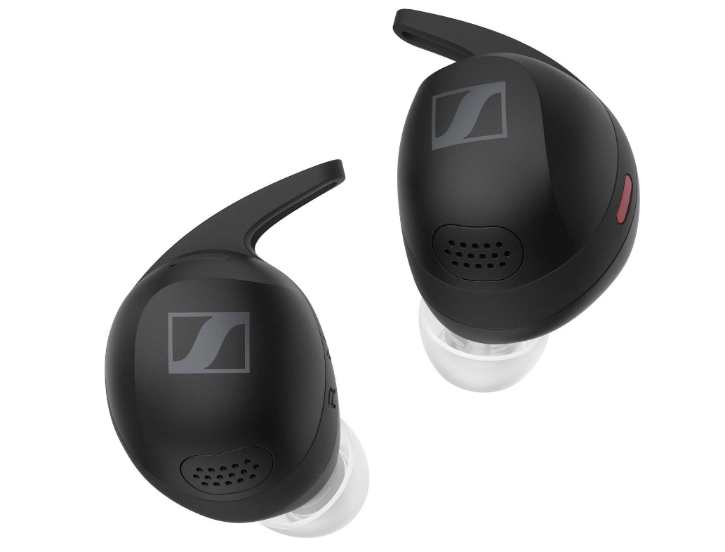
To minimise footstep noise, breathing, and other body-borne distractions, the earbuds feature an acoustic relief channel and semi-open design for natural environmental awareness. An adjustable Transparency mode, Anti-wind mode, and Adaptive Noise Cancelling mode let the wearer easily adapt as their surroundings change. The all-new acoustic system features a redesigned transducer that handily delivers the best sound quality yet in a Sennheiser sport earbud. Thanks to IP55 sweat & water resistance, a shock-proof chassis, and clog-resistant ear tips, MOMENTUM Sport are built to withstand the rigors of any workout. The equally tough IP54-rated, Qi-enabled carrying case stores up to three additional earbud recharges, extending the playback time from up to 6 hours to 24 total hours. A quick charge feature provides up to 45 minutes of playback after just 10 minutes of USB-C charging. MOMENTUM Sport will be available from April 9th. It will have an RRP of £259.99 / €329.99 EUR and come in three colourways; Polar Black, Burned Olive, and Metallic Graphite.

A full release for each product is available upon request.
About the Sennheiser brand
We live and breathe audio. We are driven by the passion to create audio solutions that make a difference. Building the future of audio and bringing remarkable sound experiences to our customers – this is what the Sennheiser brand has represented for more than 75 years. While professional audio solutions such as microphones, meeting solutions, streaming technologies, and monitoring systems are part of the business of Sennheiser electronic GmbH & Co. KG, the business with consumer devices such as headphones, soundbars and speech-enhanced hearables became part of the Sonova Holding AG group of companies in 2022, who have licensed the Sennheiser trademark for this purpose.

www.sennheiser.com
www.sennheiser-hearing.com

Press contact
Sennheiser UK&I PR agency
sennheiser@harvard.co.uk

